Date

GRIEVANCE

Dear [manager]

We wish to raise this formal grievance on behalf of our member (Name), and collectively on behalf of all other relevant employees, for refusing to accept valid exemption certificates for the covid vaccine on a permanent basis.

The points of the grievance are as follows: -
- My personal health concerns about the vaccine were dismissed without my employer [enter employers name] conducting an individual risk assessment. As vaccination is a work-related activity, this is a serious omission, in breach of employment law (Health & Safety at Work Act 1974; Management of Health & Safety at Work Regulations 1999).
- [Employer’s] insistence on me submitting the government’s exemption form is not a legal requirement. I have significant concerns about the government exemption process. My certificate fully complies with the legislation, as in Section 12.3 of the The Health and Social Care Act 2008 (Regulated Activities) (Amendment) (Coronavirus) (No. 2) Regulations 2022. Please note that the term ‘satisfies’, as it relates to exemption, does not mean in lay usage but as a legal fulfilment.
- Refusal to accept my self-declared clinical reason exemption goes against Section 12.3 of the The Health and Social Care Act 2008 (Regulated Activities) (Amendment) (Coronavirus) (No. 2) Regulations 2022 which allows self-certificate clinical reason exemptions beyond the said date.
- Refusal to accept my self-declared clinical exemption is in breach of my rights under the Equality Act 2010, which prohibits discrimination on grounds of disability / health condition. The Equality Act does not allow arbitrary time limits to be imposed on disabilities for work-related activities.
Desired resolution: We would like the self-certificate to be accepted so that our member, and all other relevant employees’, may continue in their roles without impediment.

Yours sincerely
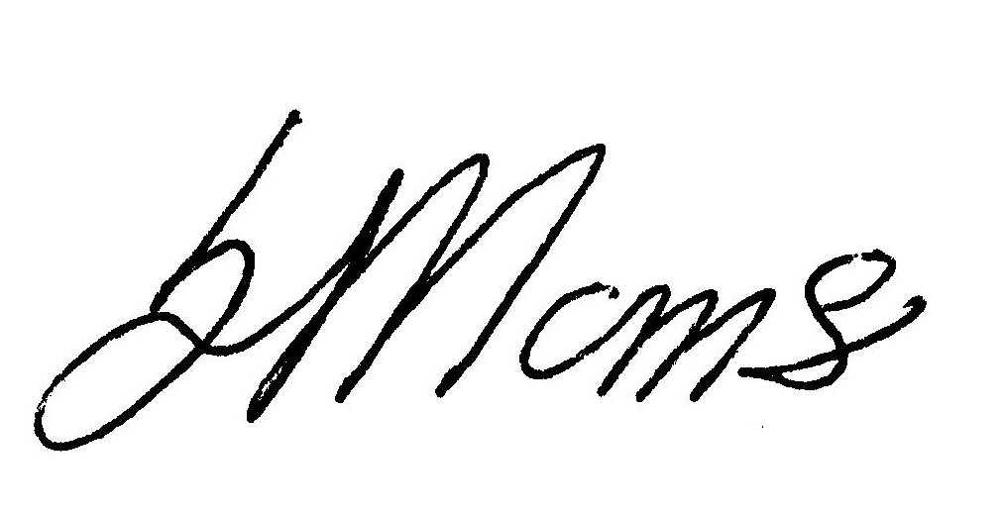

General Secretary

